BANK LOAN DATA ANALYSIS

- Datatype of each column:
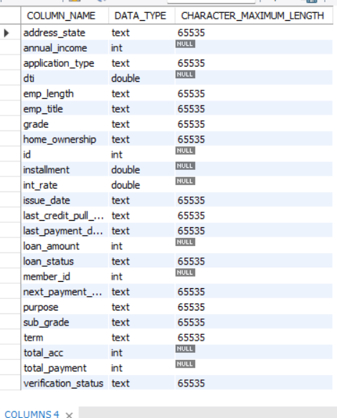
- correcting date based columns datatype text to date -

UPDATE financial_loan
SET
issue_date = STR_TO_DATE(issue_date, '%d-%m-%Y'),
last_credit_pull_date = STR_TO_DATE(last_credit_pull_date, '%d-%m-%Y'),
last_payment_date = STR_TO_DATE(last_payment_date, '%d-%m-%Y'),
nextpayment_date = STR_TO_DATE(next_payment_date, '%d-%m-%Y');

ALTER TABLE financial_loan
MODIFY issue_date DATE,
MODIFY last_credit_pull_date DATE,
MODIFY last_payment_date DATE,
MODIFY next_payment_date DATE;

- Adding Primary key to dataset
ALTER TABLE financial_loan
MODIFY id INT NOT NULL,
ADD PRIMARY KEY (id);

describe financial_loan
SET SQL_SAFE_UPDATES = 1;
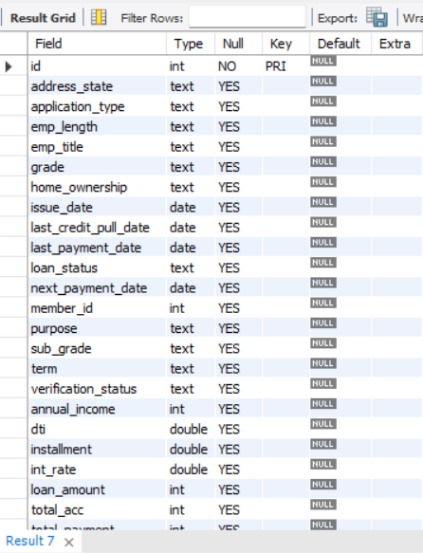

- BANK LOAN REPORT | SUMMARY
KPI’s:
Total Loan Applications
SELECT COUNT(id) AS Total_Applications FROM financial_loan
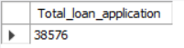
MTD Loan Applications
SELECT COUNT(id) as MTD_Total_Loan_Applications
FROM financial_loan
WHERE MONTH(issue_date) = (SELECT MONTH(MAX(issue_date)) FROM financial_loan)
AND YEAR(issue_date) = (SELECT YEAR(MAX(issue_date)) FROM financial_loan);
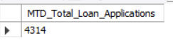

PMTD Loan Applications
SELECT COUNT(id) AS PMTD_Total_Loan_Applications
FROM financial_loan
WHERE MONTH(issue_date) = MONTH((SELECT DATE_SUB(MAX(issue_date), INTERVAL 1 MONTH) FROM financial_loan))
AND YEAR(issue_date) = YEAR((SELECT DATE_SUB(MAX(issue_date), INTERVAL 1 MONTH) FROM financial_loan));
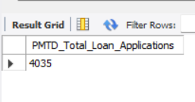

Total Funded Amount
SELECT SUM(loan_amount) AS Total_Funded_Amount FROM financial_loan
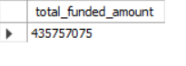

MTD Total Funded Amount
SELECT sum(loan_amount) as MTD_Total_funded_Applications
FROM financial_loan
WHERE MONTH(issue_date) = (SELECT MONTH(MAX(issue_date)) FROM financial_loan)
AND YEAR(issue_date) = (SELECT YEAR(MAX(issue_date)) FROM financial_loan);

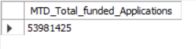

PMTD Total Funded Amount
SELECT sum(loan_amount) AS PMTD_Total_funded_Applications
FROM financial_loan
WHERE MONTH(issue_date) = MONTH((SELECT DATE_SUB(MAX(issue_date), INTERVAL 1 MONTH) FROM financial_loan))
AND YEAR(issue_date) = YEAR((SELECT DATE_SUB(MAX(issue_date), INTERVAL 1 MONTH) FROM financial_loan));

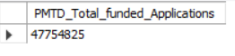

Total Amount Received
SELECT SUM(total_payment) AS Total_Amount_Collected FROM financial_loan
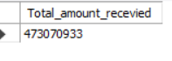
MTD Total Amount Received
SELECT sum(total_payment) as MTD_Total_Amount_recevied
FROM financial_loan
WHERE MONTH(issue_date) = (SELECT MONTH(MAX(issue_date)) FROM financial_loan)
AND YEAR(issue_date) = (SELECT YEAR(MAX(issue_date)) FROM financial_loan);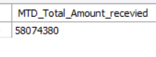

PMTD Total Amount Received
SELECT sum(total_payment) AS PMTD_Total_Amount_recevied
FROM financial_loan
WHERE MONTH(issue_date) = MONTH((SELECT DATE_SUB(MAX(issue_date), INTERVAL 1 MONTH) FROM financial_loan))
AND YEAR(issue_date) = YEAR((SELECT DATE_SUB(MAX(issue_date), INTERVAL 1 MONTH) FROM financial_loan));

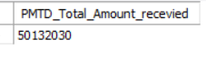

Average Interest Rate
SELECT AVG(int_rate)*100 AS Avg_Int_Rate FROM financial_loan
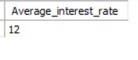
MTD Average Interest
select round(avg(int_rate),4)*100 as MTD_Average_interest_rate from financial_loan
WHERE MONTH(issue_date) = (SELECT MONTH(MAX(issue_date)) FROM financial_loan)
AND YEAR(issue_date) = (SELECT YEAR(MAX(issue_date)) FROM financial_loan);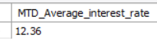

PMTD Average Interest
select round(avg(int_rate),4)*100 as PMTD_Average_interest_rate from financial_loan
WHERE MONTH(issue_date) = MONTH((SELECT DATE_SUB(MAX(issue_date), INTERVAL 1 MONTH) FROM financial_loan))
AND YEAR(issue_date) = YEAR((SELECT DATE_SUB(MAX(issue_date), INTERVAL 1 MONTH) FROM financial_loan));
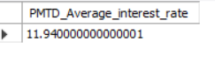

Avg DTI
SELECT AVG(dti)*100 AS Avg_DTI FROM financial_loan
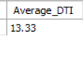
MTD Avg DTI
select round(avg(dti),4)*100 as MTD_Average_DTI from financial_loan
WHERE MONTH(issue_date) = (SELECT MONTH(MAX(issue_date)) FROM financial_loan)
AND YEAR(issue_date) = (SELECT YEAR(MAX(issue_date)) FROM financial_loan);

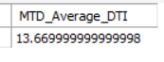
PMTD Avg DTI
select round(avg(dti),4)*100 as PMTD_Average_DTI from financial_loan
WHERE MONTH(issue_date) = MONTH((SELECT DATE_SUB(MAX(issue_date), INTERVAL 1 MONTH) FROM financial_loan))
AND YEAR(issue_date) = YEAR((SELECT DATE_SUB(MAX(issue_date), INTERVAL 1 MONTH) FROM financial_loan));

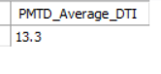

GOOD LOAN ISSUED
Good Loan Percentage
SELECT
(COUNT(CASE WHEN loan_status = 'Fully Paid' OR loan_status = 'Current' THEN id END) * 100.0) /
COUNT(id) AS Good_Loan_Percentage
FROM bank_loan_data

Good Loan Applications
SELECT COUNT(id) AS Good_Loan_Applications FROM bank_loan_data
WHERE loan_status = 'Fully Paid' OR loan_status = 'Current'

Good Loan Funded Amount
SELECT SUM(loan_amount) AS Good_Loan_Funded_amount FROM bank_loan_data
WHERE loan_status = 'Fully Paid' OR loan_status = 'Current'

Good Loan Amount Received
SELECT SUM(total_payment) AS Good_Loan_amount_received FROM bank_loan_data
WHERE loan_status = 'Fully Paid' OR loan_status = 'Current'

BAD LOAN ISSUED
Bad Loan Percentage
SELECT
(COUNT(CASE WHEN loan_status = 'Charged Off' THEN id END) * 100.0) /
COUNT(id) AS Bad_Loan_Percentage
FROM bank_loan_data

Bad Loan Applications
SELECT COUNT(id) AS Bad_Loan_Applications FROM bank_loan_data
WHERE loan_status = 'Charged Off'

Bad Loan Funded Amount
SELECT SUM(loan_amount) AS Bad_Loan_Funded_amount FROM bank_loan_data
WHERE loan_status = 'Charged Off'

Bad Loan Amount Received
SELECT SUM(total_payment) AS Bad_Loan_amount_received FROM bank_loan_data
WHERE loan_status = 'Charged Off'

LOAN STATUS
SELECT
loan_status,
COUNT(id) AS LoanCount,
SUM(total_payment) AS Total_Amount_Received,
SUM(loan_amount) AS Total_Funded_Amount,
AVG(int_rate * 100) AS Interest_Rate,
AVG(dti * 100) AS DTI
FROM
bank_loan_data
GROUP BY
loan_status

SELECT
loan_status,
SUM(total_payment) AS MTD_Total_Amount_Received,
SUM(loan_amount) AS MTD_Total_Funded_Amount
FROM bank_loan_data
WHERE MONTH(issue_date) = 12
GROUP BY loan_status

- BANK LOAN REPORT | OVERVIEW
MONTH
SELECT
MONTH(issue_date) AS Month_Munber,
DATENAME(MONTH, issue_date) AS Month_name,
COUNT(id) AS Total_Loan_Applications,
SUM(loan_amount) AS Total_Funded_Amount,
SUM(total_payment) AS Total_Amount_Received
FROM bank_loan_data
GROUP BY MONTH(issue_date), DATENAME(MONTH, issue_date)
ORDER BY MONTH(issue_date)

STATE
SELECT
address_state AS State,
COUNT(id) AS Total_Loan_Applications,
SUM(loan_amount) AS Total_Funded_Amount,
SUM(total_payment) AS Total_Amount_Received
FROM bank_loan_data
GROUP BY address_state
ORDER BY address_state

TERM
SELECT
term AS Term,
COUNT(id) AS Total_Loan_Applications,
SUM(loan_amount) AS Total_Funded_Amount,
SUM(total_payment) AS Total_Amount_Received
FROM bank_loan_data
GROUP BY term
ORDER BY term

EMPLOYEE LENGTH
SELECT
emp_length AS Employee_Length,
COUNT(id) AS Total_Loan_Applications,
SUM(loan_amount) AS Total_Funded_Amount,
SUM(total_payment) AS Total_Amount_Received
FROM bank_loan_data
GROUP BY emp_length
ORDER BY emp_length

PURPOSE
SELECT
purpose AS PURPOSE,
COUNT(id) AS Total_Loan_Applications,
SUM(loan_amount) AS Total_Funded_Amount,
SUM(total_payment) AS Total_Amount_Received
FROM bank_loan_data
GROUP BY purpose
ORDER BY purpose

HOME OWNERSHIP
SELECT
home_ownership AS Home_Ownership,
COUNT(id) AS Total_Loan_Applications,
SUM(loan_amount) AS Total_Funded_Amount,
SUM(total_payment) AS Total_Amount_Received
FROM bank_loan_data
GROUP BY home_ownership
ORDER BY home_ownership

Note: We have applied multiple Filters on all the dashboards. You can check the results for the filters as well by modifying the query and comparing the results.
For e.g
See the results when we hit the Grade A in the filters for dashboards.
SELECT
purpose AS PURPOSE,
COUNT(id) AS Total_Loan_Applications,
SUM(loan_amount) AS Total_Funded_Amount,
SUM(total_payment) AS Total_Amount_Received
FROM bank_loan_data
WHERE grade = 'A'
GROUP BY purpose
ORDER BY purpose

